Reporting
Report Cards will be sent home at the start of Week 10, both as a printed copy and an email. While formal interviews are not scheduled, please call the office if you wish to contact the teacher to talk about your child’s progress.
Colour Explosion Fun Run
Everyone is welcome to attend our Colour Fun Run on Friday 17 November from 2-3pm. More information will come home about this event in the coming weeks.

Year 6 Graduation
Our Year 6 Graduation Ceremony will be held on Wednesday 6 December. Later that day the Year 6 students will then go to the Kirwan Tenpin Bowling Centre for lunch and activities. Notes have been sent home for the excursion and with further information about the ceremony. Payment for the lunch/activities is due by Friday 20 October.

Families are welcome to attend the Graduation Ceremony – there are no limits to numbers who can attend.

High school enrolment and Transition Day
Many high schools are already accepting enrolment applications. All students who are going to a state high school will attend a Regional Transition Day in the second last week of Term 4. The students need to be enrolled at the high school to attend this day. If you child is enrolling at a non-state school the transition visit day may occur earlier.

How to contact the Year 6 team:
6A - Jenna Frenken (Mon) jmcmi55@eq.edu.au
Lisa Willcox (Tue-Fri) lgoes@eq.edu.au
6B - Matthew Ward (W,Th,F) mward304@eq.edu.au
Kylie Neill (M,T) kcnei0@eq.edu.au
6C - Nicole Demaine nmdem0@eq.edu.au

SEP Teachers
6A – Deb Barra Howard (0.2) dbarr92@eq.edu.au
6B/6C – Kaylene Robson (0.3) krobs16@eq.edu.au
Line Manager – Janelle Pepperdene jpepp13@eq.edu.au

Or phone the school on 47 595 333 to leave a message for the teacher and they will phone you back when available.

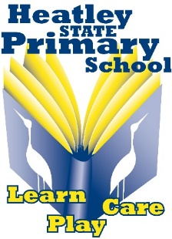 | Keep up to date with our Website and Facebook  https://heatleyss.eq.edu.au/  https://www.facebook.com/HeatleySS/  Regular school newsletters are also emailed home | 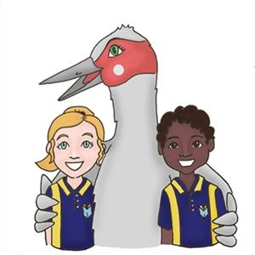

Year 6 Term 4 2023
October
Wk 1 | Monday 2 Oct | Public Holiday
Wk 1 | Tuesday 3 Oct | P&C Meeting
Wk 2 | Mon 9 to Thurs 12 Oct | Book Fair (in the Library)
Wk 4 | Tuesday 24 Oct | Camp Australia (new OHSC providers) Info Night
Wk 4 | Friday 27 Oct | Day for Daniel (Wear red)  World Teacher’s Day
Wk 4 | Friday 27 Oct | Prep4Prep commences for 4 weeks
November
Wk 5 | Thursday 2 Nov | Chappy’s Pancake Breakfast
Wk 5 | Friday 3 Nov | Crazy Sock Day
Wk 6 | Tuesday 7 Nov | P&C Meeting
Wk 6 | Friday 10 Nov | Remembrance Day Commemoration
Wk 7 | Friday 17 Nov 2-3pm | Colour Fun Run (P&C Fundraiser)
Wk 9 | Wednesday 29 Nov | Year 6 Regional Transition Day to High School
December
Wk 10 | Monday 4 Dec | Report cards sent home (email and printed)
Wk 10 | Tuesday 5 Dec | Awards Ceremony
Wk 10 | Wednesday 6 Dec | Year 6 Graduation & Bowling Party
Wk 10 | Friday 8 Dec | Last day of Term 4
English
Advertising in the media
Students will be exploring and analysing the persuasive features of advertising texts. They will create their own digital multimodal advertisement for a holiday destination and explain their creative choices.

Mathematics
Students will continue their study of number & place value. They will engage in a range of chance experiments.

Science – Biological Sciences
Life on Earth
Students explore the environmental conditions that affect the growth and survival of living things. They plan, conduct and evaluate an experiment - 'Mouldy Bread'.

HASS (Humanities and Social Sciences)
Students will examine continuities and changes in the experiences of Australian democracy and citizenship, including the status and rights of Aboriginal and Torres Strait Islander Peoples, women and children.

HPE (Health and Physical Education) – Health focus – Jo Anning
Transitions
Students will be exploring the feelings and challenges associated with making the transition to high school. They will devise and analyse strategies to assist themselves in making a smooth transition.

PE – (Physical Education) – Tracy Riley
UNITE
Students demonstrate skills to work collaboratively and play fairly to solve movement challenges.

The Arts – Music Specialist – Michelle Rush
Students will compose chants and raps and perform them using body percussion and instruments as accompaniments.

The Arts – Media Arts
Students will explain how points of view, ideas and stories are shaped and portrayed in media artworks. The students will work collaboratively using technologies to make media artworks.

French – Christine Chitteray Veeren
Students will continue working online with teachers from the Cairns School of Distance Education. This term the students will be learning about food.

Digital Technologies – Wanda Austin
Students have enjoyed creating a solution for counting Gotchas using Spreadsheet. They are now beginning to learn about the Binary System. Decoding binary numbers and understanding barcodes has sparked their interest.

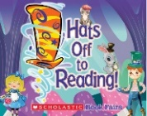
Book Fair
Book Fair will be held in the Library from Monday 9 October to Thursday 12 October. This is a great chance to buy some Christmas presents. More information is available in the Newsletter and on our website and our Facebook page.

Attendance rewards – Try for 5!
Students with greater than 90% attendance for Term 4 will
go into the draw at the end of this term for a chance to win one of these amazing
prizes – hockey table, football table, Kingpin voucher, Event Cinema voucher and
Cowboys merchandise pack.
Make every day count!

