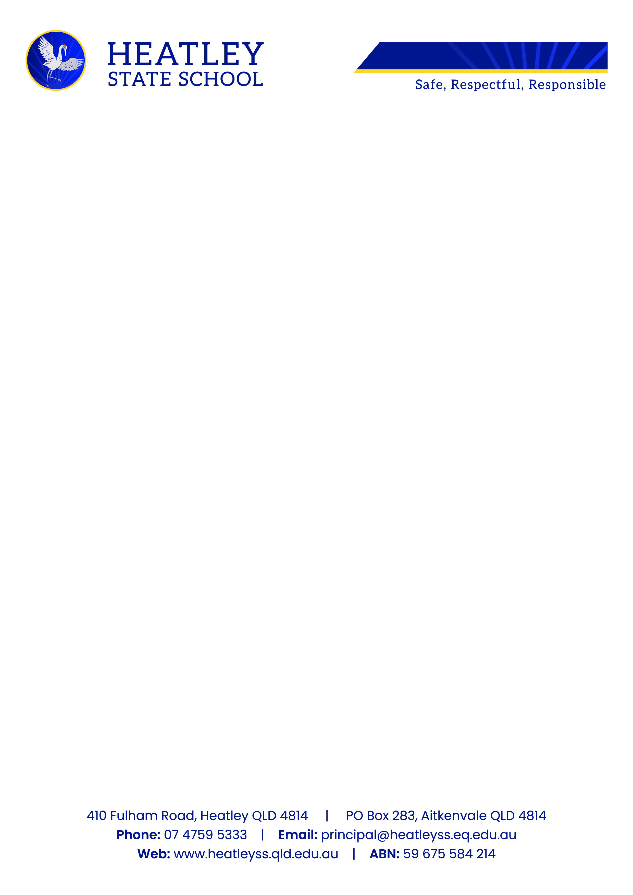
27 January 2026

Dear Parent/Guardian/Carer

Re: FREE PREP VISION SCREENING
Screening Date: TUESDAY 3rd, WEDNESDAY 4th of MARCH 2026

The Primary School Nurse Health Readiness Program is coming to your school. We are a Queensland Government service that offers Free Vision Screening to all children enrolled in Prep.
If your child is in Prep and you would like their vision screened, please complete a consent form using the below link or QR code.
Paper consent is available from the office.
Link and QR code will close on Saturday 14 February 2026.

https://visionscreening.health.qld.gov.au/ParentalConsent/1811M3vy
